Project Design Phase
Solution Architecture

Date | 14 October 2026
Team ID | ServiceNow - 92
Project Name | Medical Diagnosis Center (MDC)
Maximum Marks | 4 Marks

Solution Architecture:
The Medical Diagnosis Center uses a ServiceNow Service Portal connected to server-side application logic and related data tables. Patients and staff use the portal to access test information, manage appointments, and view medical reports. A Business Rule creates a report record when an appointment status changes to Completed.
- Provide portal pages for Home, Book a Test, My Appointments, Medical Reports, and the Admin Dashboard.
- Connect Patient, Diagnostic Test, Appointment, and Medical Report records using the ServiceNow data layer.
- Use portal widgets and server-side scripts for booking, retrieving report data, and displaying findings.
- Trigger report-record creation when an appointment changes to Completed; generated findings in this demonstration are sample content only.

MDC Solution Architecture Diagram:

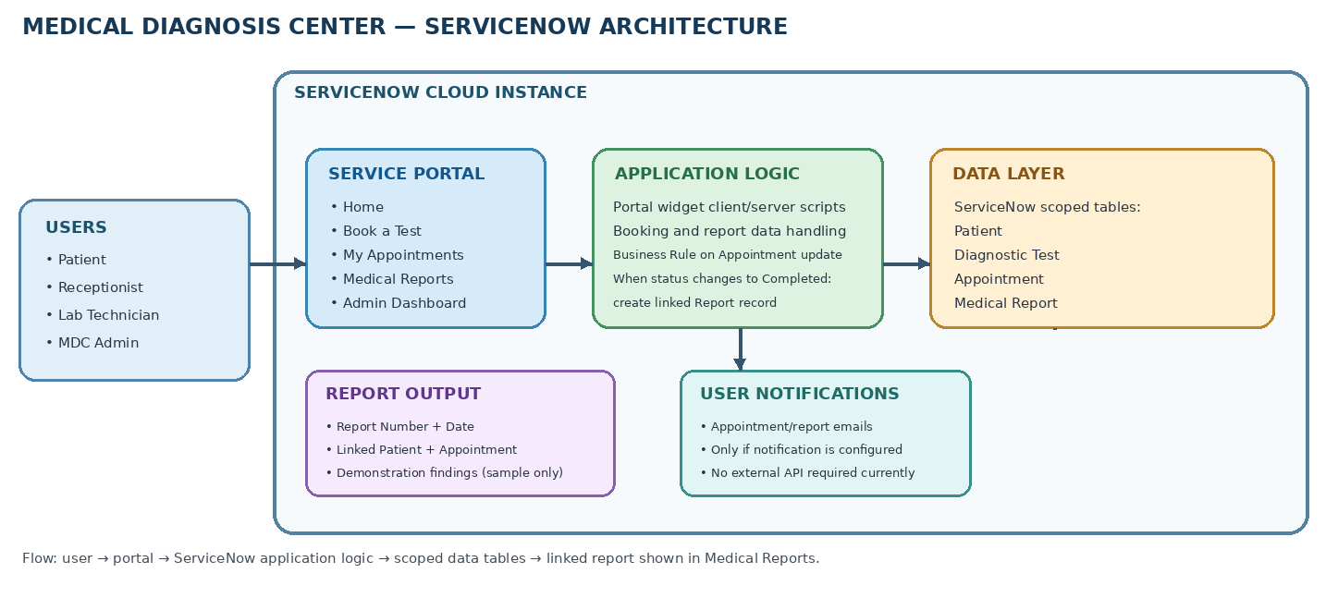Figure 1: ServiceNow architecture and data flow for the Medical Diagnosis Center (MDC)

